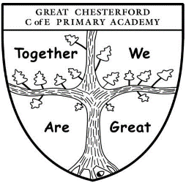

Pupil Premium and Free School Meals

Are you in receipt of any of the following?
YES/NO
- Income Support

- Income-based Jobseeker’s Allowance

- Income-related Employment and Support Allowance

- Support under Part VI of the Immigration and Asylum Act 1999

- The guaranteed element of Pension Credit

- Child Tax Credit (provided you’re not also entitled to Working Tax Credit and have an annual gross income of no more than £16,190)

- Working Tax Credit run-on - paid for 4 weeks after you stop qualifying for Working Tax Credit

- Universal Credit - if you apply on or after 1 April 2018, your household income must be less than £7,400 a year (after tax and not including any benefits you get)

If so, the school may be able to get funding, known as Pupil Premium, to provide additional support for your child. This help will go towards improving educational provision and could be used to contribute towards school costs, for example: uniform, music lessons or school trips. If you qualify for Pupil Premium, and your child is in KS2, you will also be entitled to free school meals. Please contact the school office if you think you may be eligible.

More information on Pupil Premium can be found on our website or on the gov.uk website.

