SPRING TERM HOME PE
YR 2
Treasure Hunt Walk Stamina and problem solving
Equipment: Paper and pen or list on phone
How to play: Going outside for a daily walk, scooting, cycling ,or running is a really good form of exercise.
This week make your own Treasure Hunt list for your family for when you go to the park, on a walk.
Here’s an example to start you off , but deisgn your own one too. You could take a photo of this list on on a phone or take some paper with you.

TREASURE HUNT WALK
White bird  This Photo by Unknown Author is licensed under CC BY | Post box
Green door  This Photo by Unknown Author is licensed under CC BY-NC-ND | Yellow car
The number 12 | 1yellow, 1red , 1green, 1orange & 1brown leaf .
1 white dog, 1 black dog , 1 brown dog | Litter bin
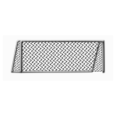  Goal posts | Ball
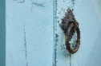  Door Knocker | 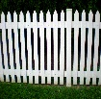  White fence
Window Shutters | Bicyle helmet

Challenge: Change the way you travel next time, so if you walked last time, can you scoot, skip, or run next time. Make up another treasure hunt for all your family to do.
STEP
Space – Change the length of walk, if you turned right out of the house, turn left this time.
Task – Change the rules of the game, perhaps take turns to find something on the list. Go on a letter treasure hunt, so everyone must find as many things beginning with the letter T.
Equipment –take a ball with you and dribble it along, or a skipping rope or a scooter.
People – have people help you or play against a family member to see who can get the most on the list.

