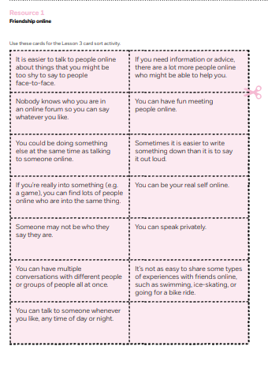
Agree/ disagree/ not sure activity

