Child Friendly Privacy Notice
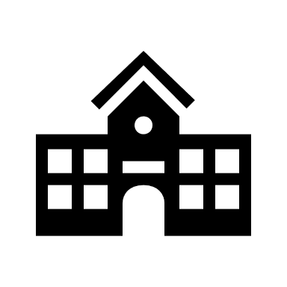
- Who are we?
We are your school. We help you learn and prepare you for the future.

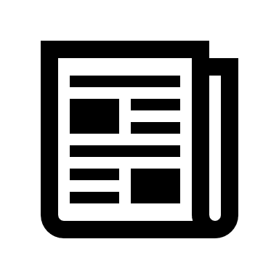
- Why do we keep personal information about you?
We use the information to teach you and keep you safe.

- What information do we keep about you?
It includes your name, where you live, who looks after you outside
school, your health, and what you have learned.

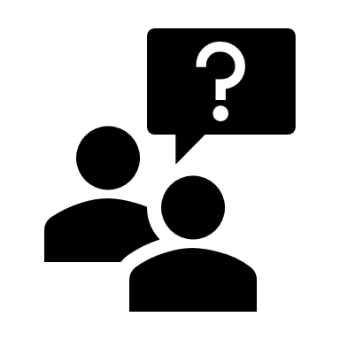
4. How do we collect information about you?
We collect information from you and your family. We also get information from others, for example your council, doctor or social worker if they tell us.

- How do we use your information?
We securely hold information about you so that we can teach you and keep you safe. Sometimes we have to share information about you. For example:
- The Government Department for Education and Local Authority
- With Examination Boards and Inspectors
- When you take part in some of our activities – such as residential trips
- Sometimes we may need to share your information if you are at risk of harm to yourself or others

6. How long do we keep your information?
We keep your information as long as we need to help you or as long as the law needs us to.

- Your rights
- We only keep information about you that we really need
- We do not share it unless we have to
- You have the right to know what we hold about you and have a copy
- You can have incorrect information corrected

For more information please speak to the school office.

