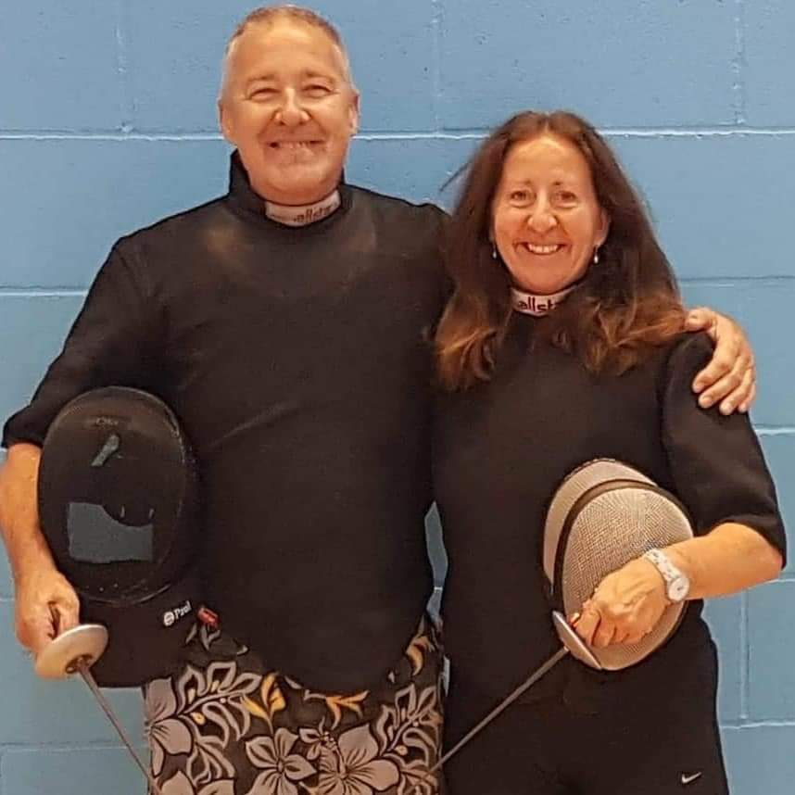
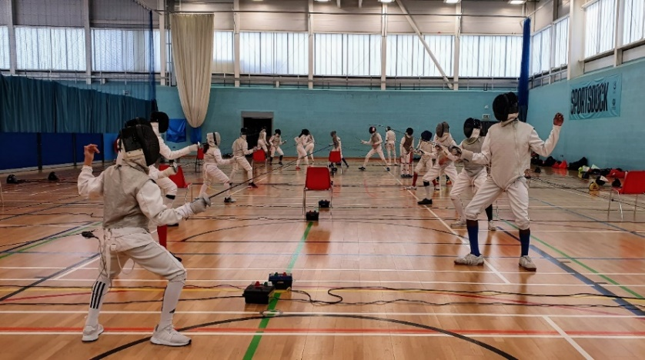
Fencing is fun and a great way to keep fit! We cater for children of all ages and adults in a friendly and all-inclusive atmosphere!

Session Day/Times (Starting June 7th 2022)
Tuesdays: 6.00 – 7.30pm - Children’s Class (Ages 9-15)
7.00 – 9.00pm - Adults Class/Experienced Fencers (Age 16+)

Coaches
Pierre Harper: Triple Olympian, 6 Times British National Senior Champion and 6 Times Commonwealth Games Gold Medallist.
Linda Strachan: Double Olympian, 7 Times British National Senior Champion and 5 Times Commonwealth Games Gold Medallist.

Booking Link
https://newhamswords.org.uk/memb-btshm/

How to Contact Us
For further information, please contact Linda Strachan on 07956618898 or email lindastrachan@hotmail.com

